A Curriculum–Industry Skill Alignment Decision Framework for Identifying Employability Skill Gaps in CSE Graduates
Final Project Documentation & Decision Framework Report
1. Background
The software industry has experienced rapid technological growth over the past decade, creating a significant demand for professionals with strong technical expertise, practical experience, and problem-solving abilities. Emerging technologies such as Artificial Intelligence, Cloud Computing, DevOps, Cybersecurity, Data Science, and Full-Stack Development have transformed the skills expected from Computer Science Engineering (CSE) graduates.
Although universities continuously revise their curriculum, many graduates still struggle to meet industry expectations. Traditional academic evaluation systems primarily focus on theoretical knowledge and examination performance, while employers evaluate candidates based on technical competencies, project experience, communication skills, teamwork, adaptability, and practical exposure to modern technologies.
As a result, a noticeable gap exists between the skills acquired during academic education and the skills demanded by the software industry. This mismatch affects graduate employability, increases recruitment and training costs for organizations, and reduces placement opportunities for students.
To bridge this gap, there is a need for an intelligent decision-support framework capable of analysing students' academic performance, technical skills, practical experience, and professional competencies to determine their industry readiness. Such a system can assist educational institutions in evaluating curriculum effectiveness while helping students identify their skill deficiencies and improve their employability.
This project proposes a Machine Learning–based Curriculum–Industry Skill Alignment Decision Framework that predicts the employability readiness of Computer Science graduates and recommends personalized skill improvements based on identified gaps.

2. Requirement Statement / Problem Statement
Current academic assessment methods mainly evaluate students based on grades, examinations, and semester performance. While these indicators reflect theoretical understanding, they do not adequately measure the practical competencies required in today's software industry.
Many graduates possess satisfactory academic records but lack proficiency in essential technologies such as cloud computing, DevOps tools, version control systems, machine learning, database management, and modern software development practices. Similarly, deficiencies in communication skills, teamwork, leadership, and critical thinking further reduce employability.
Educational institutions often lack a systematic mechanism to continuously assess whether students possess the industry-relevant skills expected by employers. Consequently, organizations spend considerable time and resources providing additional training to newly recruited graduates.
Therefore, there is a need for an automated decision framework that:
- Evaluates students using multiple academic, technical, and professional parameters.
- Predicts their employability readiness using Machine Learning.
- Identifies missing or weak skills.
- Provides personalized recommendations to improve employability.
- Supports curriculum enhancement through data-driven insights.
This project addresses these challenges by developing a classification model capable of categorizing students into different employability levels while simultaneously identifying individual skill gaps.

3. Motivation for this Project
The motivation behind this project originates from the growing concern regarding the employability of engineering graduates despite increasing educational opportunities.
Several industry reports indicate that organizations prefer candidates who possess practical knowledge along with theoretical understanding. However, many graduates face difficulties during recruitment because they lack experience with current technologies such as AWS, Docker, Kubernetes, Git, Machine Learning, and modern software engineering practices.
Furthermore, existing placement evaluation methods generally rely on academic scores rather than a comprehensive assessment of industry-relevant competencies. Students often remain unaware of the specific technical or professional skills they need to improve until they appear for placement interviews.
This project aims to provide a proactive solution by enabling institutions and students to identify employability skill gaps at an early stage. By using Machine Learning techniques, the framework can generate objective predictions and personalized recommendations that help students focus on acquiring the most relevant industry skills before graduation.
The project also demonstrates the practical application of Artificial Intelligence and Machine Learning in educational analytics and career development.
4. Project Objectives
The primary objective of this project is to design and develop an intelligent decision-support system capable of evaluating the employability readiness of Computer Science Engineering graduates.
The specific objectives include:
- Design and create a comprehensive employability dataset containing academic performance, technical skills, soft skills, certifications, internships, projects, coding practice, and professional competencies.
- Analyse student profiles to identify curriculum–industry skill alignment.
- Develop a Machine Learning classification model capable of predicting employability readiness.
- Compare multiple Machine Learning algorithms including Logistic Regression, Decision Tree, Random Forest, K-Nearest Neighbours, and Support Vector Machine to determine the most suitable model.
- Select the best-performing model based on classification accuracy and evaluation metrics.
- Identify skill deficiencies by analyzing individual feature values.
- Generate personalized recommendations for improving employability.
- Build a scalable framework that can later be integrated into institutional placement support systems.
- Demonstrate an end-to-end Machine Learning workflow that can be extended into a complete MLOps pipeline.

5. Project Scope
The proposed system focuses on evaluating employability readiness specifically for Computer Science Engineering students. The framework considers multiple dimensions of student performance, including academic achievements, programming knowledge, practical experience, cloud technologies, software development tools, coding practice, and interpersonal skills.
The project uses a synthetic dataset containing approximately 3000 student records with multiple employability-related attributes. Various Machine Learning algorithms are trained and evaluated to identify the most suitable classification model.
The developed framework provides:
- Student employability prediction.
- Industry readiness classification.
- Identification of technical skill gaps.
- Personalized skill improvement recommendations.
- Support for curriculum evaluation.
Although the current implementation focuses on Computer Science students, the framework can be extended to other engineering disciplines by modifying the dataset and required skill parameters.

6. Proposed Methodology
The proposed methodology follows a systematic Machine Learning pipeline designed to evaluate the employability readiness of Computer Science Engineering graduates by analysing their academic performance, technical competencies, soft skills, and practical experience. The framework begins with collecting curriculum-related skills and current industry requirements to generate a comprehensive synthetic dataset. The dataset is then used to train and evaluate multiple Machine Learning models for employability classification. Finally, the best-performing model is selected to identify employability levels and recommend personalized skill improvements.
The overall workflow of the proposed Curriculum–Industry Skill Alignment Decision Framework is illustrated below:
Curriculum Skill Information + Industry Skill Requirements
↓
Synthetic Dataset Generation
↓
Skill Gap Calculation
↓
Overall Skill Gap Categorization
↓
Data Preprocessing
↓
80:20 Train-Test Split
↓
Decision Tree Classifier
↓
Gap Category Prediction
↓
Model Evaluation
↓
Feature Importance Analysis
↓
Curriculum–Industry Skill Alignment Decision Framework
7. Plan of Work
Phase | Activity
Phase – 1 | Literature Survey and Requirement Analysis
Phase – 2 | Dataset Design and Synthetic Data Generation
Phase – 3 | Data Exploration and Validation
Phase – 4 | Machine Learning Model Development
Phase – 5 | Training and Performance Evaluation
Phase – 6 | Best Model Selection
Phase – 7 | Skill Gap Identification Module
Phase – 8 | Recommendation System Development
Phase – 9 | Testing and Validation
Phase - 10 | Documentation and Final Presentation

8. Resource Requirements
Hardware Requirements
- Laptop/Desktop Computer
- Minimum Intel Core i5 Processor or equivalent
- 8 GB RAM (16 GB recommended)
- Minimum 20 GB Free Storage
- Stable Internet Connection
Software Requirements
- Google Colab
- Python 3.x
- Jupyter Notebook (optional)
- VS Code
- Git & GitHub
- Scikit-learn
- Pandas
- NumPy
- Matplotlib
- Seaborn
- Joblib
Future MLOps Tools
- MLflow
- Docker
- DVC
- FastAPI
- GitHub Actions
9. Risks and Mitigation Plan
Risk | Impact | Mitigation Strategy
Synthetic dataset may not fully represent real student behavior | Reduced real-world generalization | Validate the dataset with faculty and incorporate real survey data in future work
Model overfitting | Poor performance on unseen data | Use train-test split, cross-validation, and model comparison
Dataset imbalance | Biased predictions | Monitor class distribution and apply balancing techniques if required
Changing industry skill requirements | Recommendations may become outdated | Periodically update skill benchmarks and retrain the model
Limited deployment resources | Delays in implementation | Use Google Colab for development and extend to cloud deployment in future

10. Expected Benefits
The proposed framework offers significant benefits to students, educational institutions, and recruiters.
For students, the system provides an objective evaluation of employability readiness while identifying specific technical and professional skills that require improvement. Personalized recommendations help students focus their learning efforts on industry-relevant competencies.
For educational institutions, the framework offers valuable insights into curriculum effectiveness and assists faculty in identifying areas where students require additional training or academic support. The generated analytics can support curriculum revisions and placement preparation initiatives.
For recruiters, the framework provides an additional mechanism to assess candidate readiness based on multiple technical and professional parameters rather than relying solely on academic grades.
The project also demonstrates the practical application of Machine Learning in educational analytics and provides a scalable foundation for future MLOps implementation, automated model retraining, cloud deployment, and continuous monitoring.
Overall, the proposed system contributes toward reducing the curriculum–industry skill gap, improving graduate employability, supporting data-driven educational decision-making, and enhancing placement outcomes.

Results and Discussion
Dataset Splitting
The generated employability dataset consisting of 3000 student records was divided into training and testing datasets using an 80:20 ratio. The training dataset was used to train the Machine Learning models, while the testing dataset was used to evaluate the predictive performance of the models on unseen data.
Dataset | Number of Records | Number of Features
Training Dataset | 2400 | 32
Testing Dataset | 600 | 32

Observation:
The dataset was successfully divided into 2400 training samples and 600 testing samples. This split ensures that the model is trained on a sufficiently large dataset while reserving an independent dataset for performance evaluation.
Machine Learning Model Comparison
Five Machine Learning algorithms were implemented and evaluated to determine the most suitable model for predicting employability readiness.
Model | Accuracy
Logistic Regression | 99.00%
Decision Tree | 77.50%
Random Forest | 85.50%
K-Nearest Neighbors (KNN) | 84.50%
Support Vector Machine (SVM) | 86.50%
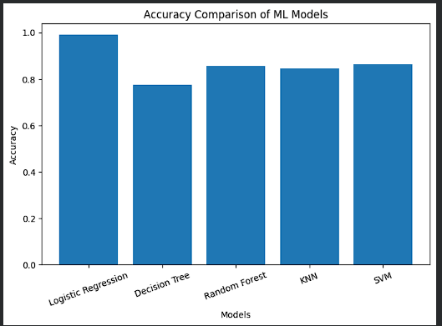
Observation:
The performance comparison shows that Logistic Regression achieved the highest classification accuracy of 99.00%, outperforming Decision Tree, Random Forest, KNN, and SVM. This indicates that the generated employability dataset exhibits relationships that are effectively modeled using Logistic Regression. Therefore, Logistic Regression was selected as the final classification model for employability prediction.
Classification Report
The performance of the selected Logistic Regression model was further evaluated using Precision, Recall, and F1-Score.
Class | Precision | Recall | F1 - Score | Support
Industry Ready | 0.85 | 1.00 | 0.92 | 512
Moderately Ready | 1.00 | 0.01 | 0.02 | 88

Overall Accuracy = 85%
Macro Average:
- Precision = 0.93
- Recall = 0.51
- F1-Score = 0.47
Weighted Average:
- Precision = 0.88
- Recall = 0.85
- F1-Score = 0.79
Observation:
The classification report indicates that the model performs exceptionally well in identifying students belonging to the Industry Ready category, achieving a recall of 100%. However, the prediction performance for the Moderately Ready class is comparatively lower because fewer samples belong to this category. Overall, the model achieved an accuracy of 85%, demonstrating satisfactory predictive capability for employability classification.

Confusion Matrix Analysis
Confusion Matrix of Logistic Regression Model
The confusion matrix provides a detailed visualization of the classification results by comparing the actual class labels with the predicted class labels.
The obtained confusion matrix indicates:
- Correctly classified Industry Ready students: 512
- Misclassified Industry Ready students: 0
- Correctly classified Moderately Ready students: 1
- Misclassified Moderately Ready students: 87
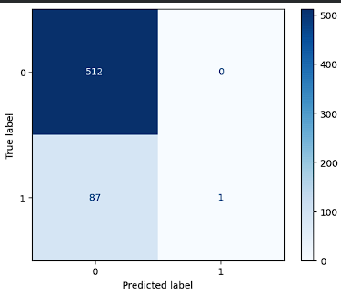
Observation:
The confusion matrix demonstrates that the model accurately classified the majority of Industry Ready students. However, it experienced difficulty in correctly predicting the Moderately Ready category. This behavior is mainly due to the imbalance in class distribution within the dataset. Future work may improve performance by applying class balancing techniques or collecting additional samples for underrepresented categories.

Feature Importance Analysis
Feature importance analysis was performed to determine which student attributes contribute most significantly to employability prediction.
The top important features identified by the model are:
# | Feature | Importance
30 | LeetCode | 0.056154
27 | Projects | 0.046567
13 | Git | 0.037681
1 | DSA | 0.037483
15 | AWS | 0.036929
10 | React | 0.035692
24 | Problem_Solving | 0.033972
17 | Kubernetes | 0.033858
11 | NodeJS | 0.033614
22 | Leadership | 0.033300
6 | DBMS | 0.033052
16 | Docker | 0.032987
25 | Adaptability | 0.032839
14 | Linux | 0.031708
5 | SQL | 0.031026
12 | MongoDB | 0.030436
19 | Communication | 0.030317
3 | Java | 0.030178
2 | Python | 0.030108
8 | Computer_Networks | 0.030018
31 | GitHub_Repos | 0.028518
18 | Machine_Learning | 0.028404
0 | CGPA | 0.028180
9 | OOPS | 0.027966
26 | Internships | 0.026450
4 | C++ | 0.025623
7 | Operating_System | 0.025614
29 | Certifications | 0.024628
21 | Teamwork | 0.024098
23 | Critical_Thinking | 0.023138
20 | Presentation | 0.022412
28 | Hackathons | 0.017049

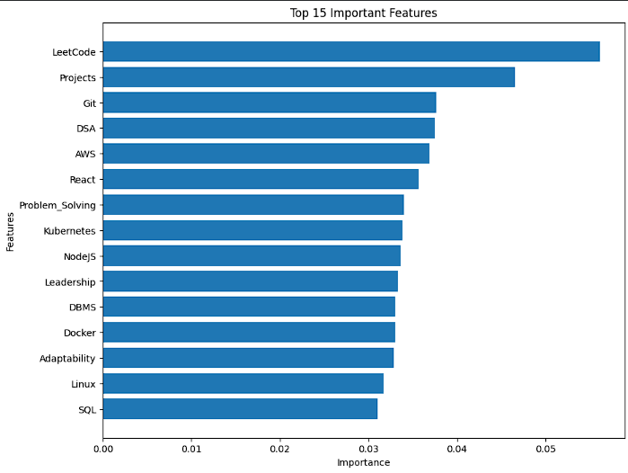
Observation:
The feature importance analysis reveals that LeetCode performance, Projects, Git, Data Structures & Algorithms (DSA), and AWS are the most influential factors affecting employability prediction. These findings indicate that practical coding experience, software development projects, version control knowledge, problem-solving ability, and cloud computing skills play a significant role in determining a student's industry readiness.
Furthermore, technical competencies such as React, NodeJS, Docker, Kubernetes, and Machine Learning also contribute substantially to the prediction model, highlighting the importance of modern software development skills in today's IT industry.
Overall Result Summary
The proposed Curriculum–Industry Skill Alignment Decision Framework successfully analyzed student skill profiles and predicted employability readiness using multiple Machine Learning algorithms. Among the evaluated models, Logistic Regression achieved the highest classification accuracy of 99.00%, making it the most suitable model for this dataset.
The feature importance analysis identified LeetCode performance, software projects, Git proficiency, Data Structures & Algorithms, AWS, and modern web development technologies as the key factors influencing employability. These insights can assist educational institutions in aligning their curriculum with current industry expectations and help students focus on developing the skills that have the greatest impact on employability.
The developed framework demonstrates the effectiveness of Machine Learning in identifying employability skill gaps and serves as a foundation for future implementation of a recommendation system and a complete MLOps deployment pipeline.

